**MONGO DB DAY 2- CRUD Operation**

CREATE Operation: Insertion

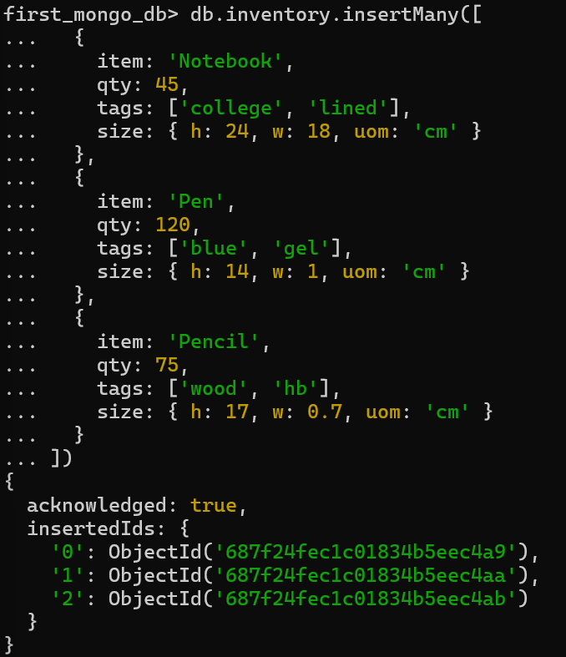

Read Operation: Find  
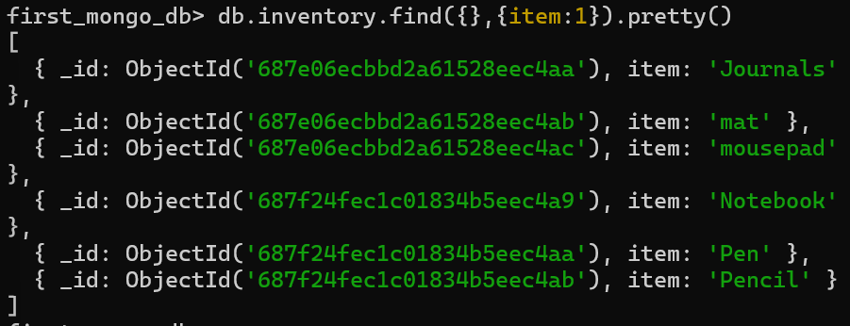

Update Operation: UpdateOne  
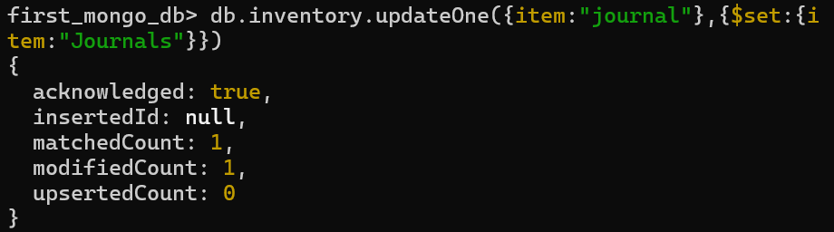

Update Operation: UpdateMany

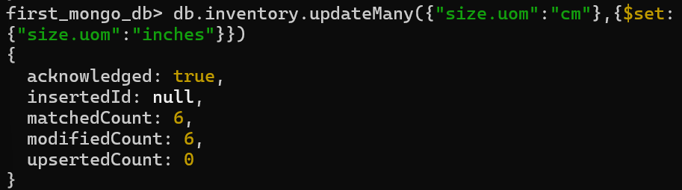

Delete Operation: deleteOne

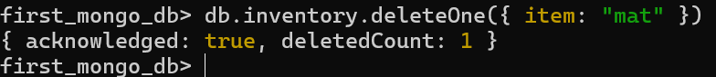

Delete Operation : deleteMany

